C Programming – Revision Notes

Recursion in C

Definition
A function that calls itself is known as “Recursion”.
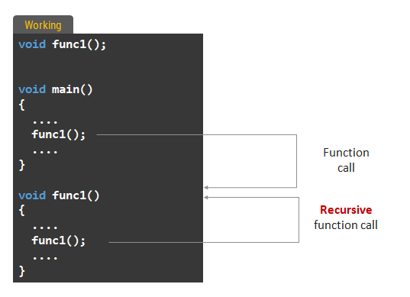

Why We Need Recursion?
- Easy Solution for recursive defined solution
- Complex program can be easily written with less code

General Structure of a Recursive Function in C

return_type function_name(parameters) {
if (base_condition) // Base case
return value;
else
return function_name(smaller_problem); // Recursive call
}

Termination condition/Base case is must otherwise it will go in an infinite loop

Print number using recursion
